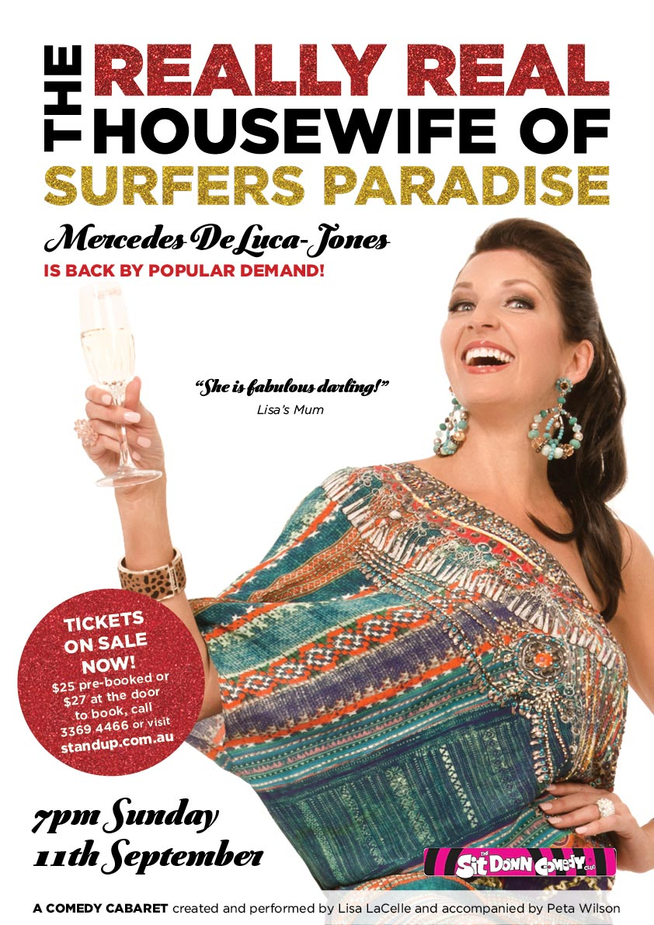

PRESENTER’S INFORMATION

**CONTENTS**

COMPANY PROFILE 3

ABOUT THE SHOW 3

PERFORMANCE SPECIFICS 6

AUDIENCE ENGAGEMENT 7

MARKETING 7

PRODUCTION DETAILS 13

CONTACTS 15

# COMPANY PROFILE

As a stand up comedienne, Lisa LaCelle has worked with the likes of Kitty Flanagan and Denise Scott in venues such as Brisbane’s Sitdown Comedy Club, Gold Coast Arts Centre, Jupiter’s and Treasury Casinos, the Melbourne Comedy Festival, as well as a tour of New Zealand. Lisa has also written and performed sets for various corporate clients including Telstra, Flight Centre and Surf Life Saving Australia. As a vocalist she has performed in various clubs, including the Brisbane Jazz Club where she has recently enjoyed four sell out shows. This production is the first cabaret LaCelle has written, combining her skills as a writer, comedienne and singer. LaCelle has also owned and run a furniture business both in the UK and in Australia and prides herself on her professionalism, business acumen and marketing abilities.

Peta Wilson has featured as Musical Director on “So Unusual - Confessions of a Lauper Stalker” at the QLD Cabaret Festival, and “The Devil Wears Leigh Buchanan”, which sold out at Wonderland (Brisbane Powerhouse), and Feast Festival (Adelaide). Peta has also accompanied Jenny Wynter for the Brisbane Comedy Festival at the Powerhouse and Woodford Folk Festival and Carita Spencer aka Dame Farrar at the Melbourne Comedy Festival.

LaCelle hopes to tour the Really Real Housewife of Surfers Paradise and feels the essence of the show is relatable to all women and to provide a light hearted, reflective and entertaining performance.

# ABOUT THE SHOW

Numerous nights sleeping on a dodgy blow up mattress in the lounge room of a Gold Coast apartment, had Lisa LaCelle religiously awake at 2am. With paid TV for company she whiled away her waking hours, being drawn into the Real House Wives of Orange County, followed by RHWO Atlanta, RHWO New York and our own RHWO Melbourne. Amazed, entertained and sometimes horrified by the women’s behaviour, LaCelle posed the question: why would someone with seemingly ‘everything’ want to air their dirty La Perlas out in public? And so, in the wee small hours of that steamy summer morning, Mercedes DeLuca-Jones was conceived and the Really Real Housewife of Surfers Paradise was born!

**The Really Real Housewife of Surfers Paradise**

She’s just an average girl…but with better shoes!

Mercedes DeLuca-Jones is in a rut. Her BFF (and top fashion designer) Richie, has just passed away leaving a void in her heart and wardrobe... and voices in her head. Her husband’s eyes (and other bits) are straying; not that she really minds, she’s been trying to get rid of him for years. Her children have both left home and travelled to Nepal to ‘give something back’ (she still doesn’t know what) and her body is starting to do things that frankly she finds hideous.

So, when ‘The Real Housewives Of’ franchise open auditions for a Gold Coast reality show, Mercedes realises it’s her destiny! This part-time model/singer/actor/interior designer/dancer/mother/wife and medium has upped the ante from triple threat to Octo-threat.

Marvel as Mercedes DeLuca-Jones explores every avenue of her abundant assets to become the next Really Real House Wife of Surfers Paradise!

This one woman comedy cabaret will tap into the heart and mind of the middle aged misfit in all of us, desperate to hang onto her youth and make her mark in this world, with or without a man. Created and performed by popular jazz singer/comedian Lisa LaCelle and accompanied by every ones’ favourite lady of the keys, Peta Wilson.

## **ACKNOWLEDGEMENTS**

## Performer/Producer/Creator - Lisa LaCelle

Director - Alison St Ledger

Pianist/Musical Director - Peta Wilson

## **BIOGRAPHIES**

LISA LACELLE has a voice as warm, colourful and sultry as her stage persona. A seasoned performer in many genres, Lisa’s first solo was at 13 singing ‘I am Woman’. The next 30 years has seen her in musical theatre, cabaret and comedy performances including vox pox on B105 and FM 104.

As a stand up comedienne, Lisa has worked with the likes of Judith Lucy, Kitty Flanagan and Denise Scott in venues such as Brisbane’s Sitdown Comedy Club, Gold Coast Arts Centre, Jupiter’s and Treasury Casinos, the Melbourne Comedy Festival, as well as a tour of New Zealand. Lisa has also written and performed sets for various corporate clients including Telstra, Flight Centre and Surf Life Saving Australia.

While her comedy featured many song parodies it wasn’t until Lisa returned from living in the UK that she decided to take her singing seriously (pardon the pun). She has performed in various clubs, including the Brisbane Jazz Club where she has recently enjoyed 4 sell out shows. Lisa has also performed at numerous private events and corporate functions with some of the country’s finest musicians.

Lisa regularly acts as Master of Ceremonies at charity and community events for clients including Zonta and Make a Wish.

ALISON ST LEDGER is one of Queenland’s finest and most versatile performers. She is best known for her involvement in Women in Voice sharing the stage with some of Australia’s leading female talent such as Katie Noonan, Kate Miller-Heidke and the legendary Chrissie Amphlett. As a singer /song writer Alison has produced an album of her own compositions and recorded as a guest vocalist with numerous bands including Powderfinger, touring throughout Australia and New Zealand with them and making numerous television appearances on Rove Live, The Panel and Sunrise. She has been the recipient of a Matilda Award and a Golden Gibbo Award at the Melbourne Comedy Festival. Alison is currently chair of the board and programming director of the Brisbane Cabaret Festival.

PETA WILSON - Since completing a Masters of Music Degree at QUT, Peta Wilson has been active in the Brisbane music scene for the past 15 years. With a major in jazz piano, Peta has gigged with several bands ranging from jazz duos to original funk outfits. Whilst she generally completes many of the compositions and arrangements for various projects, she has also recently composed for short films and television commercials. Peta has played on the recordings of her compositions, and has also done session work for other recording engineers and local acts throughout Brisbane.

Peta has toured on behalf of the QLD Arts Council and performed at a number of music festivals, including the Woodford Folk Festival, Parklife, Island Vibe, the International Brisbane Jazz Festival and Melbourne Jazz Festival, and the Norfolk Island Jazz Festival. She has written and played on a number of recordings that have received Triple J airplay and featured on ABC 612.

Peta has performed in bands such as Miguel, Ruby Blue, Kooii, The Rooftops, Cuca Shop, MKO, Radio Club Band, Scat Man Du, Gorgonzola and Fish Lane. She also works with a number of Brisbane jazz vocalists and entertainers.

Recently Peta has featured as Musical Director on “So Unusual - Confessions of a Lauper Stalker” at the QLD Cabaret Festival, and “The Devil Wears Leigh Buchanan”, which sold out at Wonderland (Brisbane Powerhouse), and Feast Festival (Adelaide). Peta has also accompanied Jenny Wynter for the Brisbane Comedy Festival at the Powerhouse and Woodford Folk Festival and Carita Spencer aka Dame Farrar at the Melbourne Comedy Festival.

# PERFORMANCE SPECIFICS

DURATION: 60 minutes (no interval)

SUITABLE VENUES: Theatre, halls, black box

MAXIMUM PERFORMANCES PER WEEK: 6 performances

## MAXIMUM PERFORMANCES PER DAY: 2

## MINIMUM BREAK BETWEEN PERFORMANCES: 120 minutes

## APRA OBLIGATIONS: Casual license required

## TOURING PERSONNEL: 2 cast, 1 crew

|  |  |
| --- | --- |
| Name | Role |
| Lisa LaCelle | Performer |
| Peta Wilson | Pianist |
| TBA | Tour manager |

## **PERFORMANCE HISTORY**

The Really Real Housewife of Surfers Paradise has been performed in April and July of 2016 to full houses at the Sitdown Comedy Club in Paddington Brisbane.

# 

# 

# AUDIENCE ENGAGEMENT

## OVERVIEW

A post performance talk is available, giving the audience an option to ask questions about the show and its production. Alternatively, a workshop is also available covering subjects such as basic vocal warm-ups, character development etc this would be available for 12 years and over and hopefully encourage an interest for younger people that are looking at getting into or show interest in performing. The character Mercedes DeLuca-Jones would be available for Master of Ceremony/host for any community events such as calling bingo etc. Mercedes DeLuca-Jones performed at the Project Pink Fundraiser at the Real Housewives of Bulimba Breakfast in July.

## DESCRIPTION / DETAILS

Cost for workshop would be based on a per person cost. For cost of Master of Ceremonies and Jazz gig please contact the producer.

## TARGET AUDIENCE FOR COMMUNITY ENGAGEMENT

The workshop would be available to anyone over 12 years with no previous experience just an interest in performance, the Producer would contact local schools and community groups as well as provide the venue of the Really Real Housewife of Surfers Paradise with flyers for promotion. The Jazz gig would be open to anyone the venue felt appropriate i.e. just residents or residents, friends and families.

# MARKETING

## MARKETING COPY

**One Line**

She’s just an average girl…but with better shoes!

**Short**

Mercedes DeLuca-Jones is in a rut. Her BFF Richie has just passed away leaving a void in her heart and voices in her head. Her husband is straying; her children have both left home and travelled to Nepal to ‘give something back’; and her body is starting to do things that frankly she finds hideous.

So when ‘The Real Housewives of’ franchise open auditions for a Gold Coast reality show, Mercedes realises it’s her destiny!

Marvel as Mercedes DeLuca-Jones explores every avenue of her abundant assets to become the next Really Real Housewife of Surfers Paradise.

**Extended**

The Really Real Housewife of Surfers Paradise

She’s just an average girl…but with better shoes!

Mercedes DeLuca-Jones is in a rut. Her BFF (and top fashion designer) Richie, has just passed away leaving a void in her heart and wardrobe... but voices in her head. Her husband’s eyes (and other bits) are straying; not that she really minds, she’s been trying to get rid of him for years. Her children have both left home and travelled to Nepal to ‘give something back’ (she still doesn’t know what) and her body is starting to do things that frankly she finds hideous.

So, when ‘The Real Housewives Of’ franchise open auditions for a Gold Coast reality show, Mercedes realises it’s her destiny! This part-time model/singer/actor/interior designer/dancer/mother/wife and medium has upped the ante from triple threat to Octo-threat.

Marvel as Mercedes DeLuca-Jones explores every avenue of her abundant assets to become the next Really Real House Wife of Surfers Paradise!

This one woman comedy cabaret will tap into the heart and mind of the middle aged misfit in all of us, desperate to hang onto her youth and make her mark in this world, with or without a man. Created and performed by popular jazz singer/comedian Lisa LaCelle and accompanied by every ones’ favourite lady of the keys, Peta Wilson.

Numerous nights sleeping on a dodgy blow up mattress in the lounge room of a Gold Coast apartment, had Lisa LaCelle religiously awake at 2am. With paid TV for company she whiled away her waking hours, being drawn into the Real House Wives of Orange County, followed by RHWO Atlanta, RHWO New York and our own RHWO Melbourne. Amazed, entertained and sometimes horrified by the women’s behaviour, LaCelle posed the question: why would someone with seemingly ‘everything’ want to air their dirty La Perlas out in public? And so, in the wee small hours of that steamy summer morning, Mercedes DeLuca-Jones was conceived and the Really Real Housewife of Surfers Paradise was born!

**MARKETING SUMMARY**

The Really Real Housewife of Surfers Paradise has a readymade marketing hook, as the "Real Housewives of" continues to be a popular reality television phenomenon. The producer has set up a Facebook page and Instragram account for her alter ego, Mercedes DeLuca-Jones (who has almost 200 friends in 2 days) providing 'advice' on lifestyle, fashion. The producer has also up a website for The Really Real Housewife of Surfers Paradise.

<http://mercedesdelucajones.wixsite.com/reallyrealhousewife>

A Youtube promo Clip filmed live at the Sitdown Comedy Club in April as well as a prilimar YouTube clip (as below) gives a concise background of Mercedes DeLuca-Jones (the main character of the show) and the general tone of the show. The clip also features Mercedeisms.com, the character's own fictional home wares/clothing website; the producer is working with a designer to produce 'Mercedeism' merchandise: T-shirts, tea towels etc which will be available for purchase at performances.

The producer will provide venues with high quality posters for distribution.

The target audience for the production is 25-85 year old women who have felt insecure, unattractive or aging and the men who try to understand them! Once a venue is selected the producer will undertake a campaign of paid Facebook advertising for the performance.

**REVIEWS**

Lisa performs with style, passion and more than just a bit of witty humour…Superbly entertaining and fun evening.

*- David Herbert, Vice President, The Brisbane Jazz Club.*

Lisa’s presence on stage was captivating...she made them laugh, clap, cry and sing.

*- Cath McCourt, audience member.*

She shines throughout every performance and her shows are a clever balance of sultry vocals and witty banter.

*- Maree Adshead, audience member*

**COLLEAGUE RECOMMENDATIONS**

She manages to combine goofy and glamour in a perfect mix! Lisa knows how to round up a crowd and they all go home feeling like they’ve found a new bestie. Never fails to impress!

*-Fedele Crisci, Owner/Producer Sitdown Comedy Club*

## **VIDEO LINKS**

<https://www.youtube.com/watch?v=42kfnTqbuSc>

<https://www.youtube.com/watch?v=6W9MTg_TCdU>

## **IMAGES**

Images by Forough Yavari of FY Photography

<https://www.dropbox.com/home/Lisa%20MacKay/Edited%20photos%20for%20application>



Sample of posters to be provided to venues.

## C:\Users\Paul\Desktop\greendress.jpg

Ahh…I ‘m not finished

## **MARKETING MATERIALS**

There will be flyers, posters, behind the scenes footage and a Mercedes DeLuca-Jones facebook page promoting venues and giving her ‘worldly’ advice on fashion, men, travel etc. There is also the YouTube clip (as per link above) giving a background of ‘Our girl Mercedes’. A website is being set up and Mercedeism merchandise will be available for purchase. At the preview at the Sitdown Comedy Club in April the performance will be filmed and clips will be available for promotion as well as ‘live’ photography.

## **CONTENT WARNINGS / AUDIENCES TO AVOID**

Over 18 audience-strong language warning

# PRODUCTION DETAILS

## **TECHNICAL SUMMARY**

Lighting and sound plot/sound check

Ability to position mock change room supplied by performer (160x220x70cm)

Tuned piano - or – electric keyboard (88 weighted keys)

Low and high mics on piano – or 2 x Dls to mic keyboard

FOH speaker (ability to get 110bd evenly across venue)

Fold back speakers (in large venues)

## **EXAMPLE SCHEDULE**

Basic bump in schedule

2.30 pm Bump in – including basic lighting pre-rig and focus lighting

5.30 pm sound check

7.30 pm Lights up

## **CREW REQUIRED FROM VENUE**

1-2 crew from venue to assist with bump in and lighting/sound (3 hours)

At least one crew from venue –sound check through performance for lighting or sound (3 hours)

Larger venues 2 crew from venue for sound check through performance for lights and sound (3 hours)

## **STAGE**



Based on a 4.5 x 3 m minimum stage

Producer to supply

Sitting chair & mock dressing room (for on stage)

Company will provide an electronic keyboard where a suitable piano/keyboard is not available

Producer will provide Shure Quad receiver and Wireless Bodypack Trasmitter and Headset

Venue to supply

Lighting and sound plot/sound check

Ability to position mock change room supplied by performer (160x220x70cm)

Tuned piano or electric keyboard (88 weighted keys)

Low and high mics on piano – or 2 x Dls to mic keyboard

6 channel mixing desk and input for CD/laptop

FOH speaker (ability to get 110bd evenly across venue)

Fold back speakers (in large venues)

## **LIGHTING**

Standard lighting rig

## **SOUND**

Low and high mics on piano – or 2 x Dls to mic keyboard

6 channel mixing desk and input for CD/laptop

FOH speaker (ability to get 110bd evenly across venue)

Fold back speakers (in large venues)

## **WARDROBE**

Venue to supply

A dressing room with hanging rack and a washing machine would be appreciated but not necessary.

## **FREIGHT NOTES**

The Producer will freight elements needed for the performance. Should the producer be unable to freight props such as the sitting chair due to flying the producer will source a sitting chair appropriate.

## **CRITICAL ISSUES**

No critical issues other than course language.

# CONTACTS

Lisa LaCelle

0404 046 888

hello@lisalacelle.com